Karen Ann Heilers
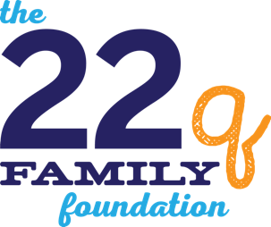
1234 School Drive
Louisville, KY 40229

November 1, 2019

Dear ,

(Share your individual story here):It took five years for someone in the health care profession to realize my grandson’s many health issues (one kidney at birth, vision difficulties at age 2, behavioral issues and ADHD diagnosis at age 4 and now velopharyngeal insufficiency) are all related to a missing portion of his 22nd chromosome. We breathed a sigh of relief when the diagnosis of 22q11.2 Deletion Syndrome was finally made!

The years leading up to the diagnosis were difficult for my daughter and her family as they struggled with many different doctor appointments and clinic visits for seemingly unrelated medical issues. That is one of the reasons why Lindsey Garcia, Executive Director of The 22q Family Foundation, and I are working to bring 22q awareness to young families in the (your city name) area.

Children and young adults with the deletion often have very complicated learning profiles and most need carefully crafted educational programs to be successful. The 22q Education Station is designed to foster a collaborative working relationship between families and schools to provide a framework by which informed educational decisions can be made that are supported by scientific research in the area of students with the 22q11.2 deletion. The Foundation provides this private consulting service free of charge.

It is our hope that you might take a minute or two to read the enclosed brochure and check out The 22q Family Foundation’s website: 22qfamilyfoundation.org.

Help us spread 22q awareness to local families who may not know of the second most common syndrome that affects 1 out of every 2,000-4,000 births…second only to Down Syndrome.

Thank you for your time and consideration. Sincerely,

(Insert Name) on behalf of
Lindsey Garcia, Executive Director The 22q Family Foundation

