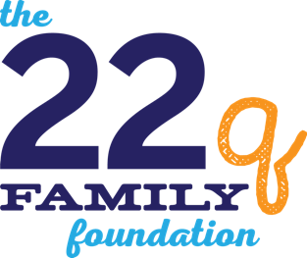
Dear Editor,

22q11.2 Deletion Syndrome (22q) is the second most common genetic disorder in children. The absence of a portion of the 22nd chromosome affects every system in the body and is evident in one out of every 2,000-4,000 births. It is second only to Down Syndrome in prevalence.

November is 22q Awareness Month. Efforts are underway to raise 22q awareness nationally and on a global scale, yet here in (insert name of city) 22q11.2 Deletion Syndrome is nearly unheard of.
A diagnosis of 22q11.2 Deletion Syndrome is often delayed or missed entirely due to the confusion caused by the many names with which it has been known in the past, names like DiGeorge Syndrome (DGS), velo-cardio-facial syndrome (VCFS), conotruncal anomaly face syndrome (CTAF) and Shprintzen Syndrome to mention a few, and because each person diagnosed with 22q presents with a unique set of the possible 180+ symptoms, making it difficult for even the best doctors to recognize.
Some of the symptoms that may or may not be evident at birth include: growth delays, feeding problems, congenital heart disease, gastrointestinal difficulties, serious breathing concerns, cleft and craniofacial issues, calcium deficiencies, immune deficiencies, kidney problems, and skeletal anomalies. This list also includes the possibility of speech, developmental and cognitive delays, as well as ADHD, Autism and many anxiety-type disorders.
Early detection is critical and can lead to earlier interventions and better outcomes for affected individuals and their families. Each day brings us a new opportunity to encourage health care professionals to increase their understanding and knowledge of 22q, to offer assistance and resources to those in the field of education through the free services provided by The 22q Family Foundation’s Education Station, to offer tools to help individuals in the 22q community find a career that matches their skills set and interests and, most importantly, to give help and hope to parents who journey through life dealing with different diagnoses, doctor and clinic visits and countless hours of therapy for their child, not knowing the underlying cause for their child’s poor physical, mental, social or emotional growth.
We encourage you to take a few moments to learn more about 22q then share what you have learned with someone else. You can find more information online at 22qfamilyfoundation.org or send inquiries to info@22qfamilyfoundation.org.

Help us raise 22q awareness in (your state)… for the children’s sake.

(Your Name)
(Your City)

Lindsey Garcia, Executive Director The 22q Family Foundation Aptos, CA

For verification purposes only: (Your contact information)

Lindsey Garcia, Executive Director The 22q Education Foundation
725 Clubhouse Dr., Aptos, CA 95003
831-200-4227

